THE BATTLE OF NEIGHBORHOODS

Opening a new Indian restaurant in Bucharest

***IBM Data Science Professional Certificate – Capstone Project***

***Vipin Nair – Dec 2020***

1. Introduction
   1. Background:

Bucharest is the capital and largest city of Romania, as well as its cultural, industrial, and financial center. It is located in the southeast of the country, at coordinates: 44°25′57″N 26°06′14″E, less than 60 km (37.3 mi) north of the Danube River and the Bulgarian border. [1]

Bucharest is the center of the Romanian economy and industry, accounting for around 24% (2017) of the country's GDP and about one-quarter of its industrial production, while being inhabited by 9% of the country's population. Bucharest has **1.883.425**(2018) populations and consists of **6 sectors**. Neighborhoods and populations in sectors are as below (2016): [1]

* **Sector 1** *(population 227,717):* Dorobanți, Băneasa, Aviației, Pipera, Primăverii, Dămăroaia, Grivița
* **Sector 2** *(population 357,338):* Pantelimon, Colentina, Iancului, Tei, Floreasca, Moșilor, Obor, Fundeni,
* **Sector 3** *(population 399,231):* Vitan, Dudești, Titan, Centrul Civic, Dristor, Lipscani
* **Sector 4** *(population 300,331):* Berceni, Olteniței, Progresul, Văcărești, Tineretului
* **Sector 5** *(population 288,690):* Rahova, Ferentari, Giurgiului, Cotroceni, 13 Septembrie, Dealul Spirii
* **Sector 6** *(population 371,060):* Giulești, Crângași, Drumul Taberei, Militari, Grozăvești(Regie), Ghencea

As stated by the Mercer international surveys for **quality of life** in **231** cities around the world, Bucharest occupied the **109th** place in 2019. Bucharest, at number 109, ranks low in the European list but better than other European cities such as Sofia (116th) and Belgrade (139th). [2]

* 1. Problem:

In this project, I will investigate that if there is any good location in Bucharest for opening Indian restaurant.

* 1. Interest:

Anyone who wants to open a restaurant in the specified area by modifying the parameters, will be interested in this project.

1. Data
   1. I got the sector data of Bucharest from Wikipedia
   2. I got the neighborhood data of Bucharest from Wikipedia
   3. I used python geocoder library to get geographical coordinates of neighborhoods
   4. I used **Foursquare API** **venues explore** method to get the venues of given neighborhoods of Bucharest
   5. I used **Foursquare API venues method** to get ranks and likes of restaurants by given venue id

## 2.2 Feature Selection and Data Usage

* Neighborhood location values to analyze Bucharest geographical structure will be used and use of folium library of python to draw maps by using given latitude and longitudes of neighborhoods will be done. Selected features will be as below

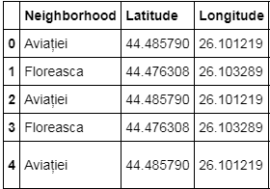

* As per the assumption populations of neighborhoods who has big population may need a new restaurant.

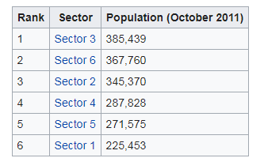 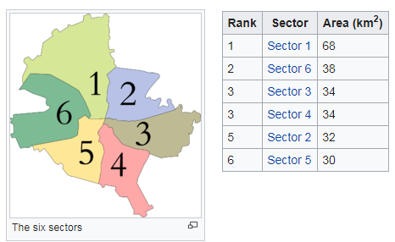

* Will also classify neighborhoods by using venues distribution and counts. In this way, I will find similarities of neighborhoods which will help me to choose location for opening a new restaurant. Similar structured neighborhoods may handle same type of venue.

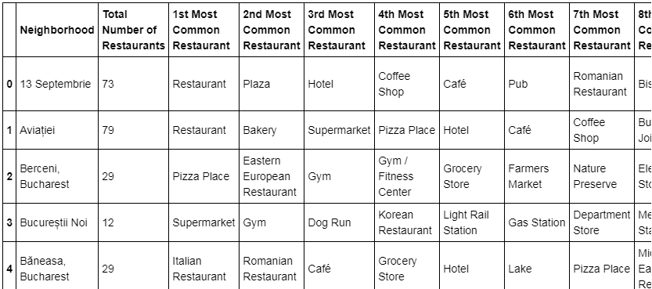

* Venue list category to find distribution of restaurants and Indian restaurants in neighborhoods will be used.
* I will use also ratings and likes of restaurants in the areas. It may help me to find location with bad rating restaurants which may need a new restaurant.

